Flexible Working Agreement

Contents
- Flexible Working Agreement and declaration  - Appendix A  Display screen equipment (DSE) assessment of flexible workers  DSE Workstation Assessment Checklist | Pages 2 – 10  Page 11  Occupational Safety website  Occupational Safety website

E-learning required
Information Security e-learning has been completed | Date:  …….../…..…./…..….

The equipment that has been issued to you as part of flexible working arrangement, please tick:

Name

Post title

Department

Service area

Employee signature

Print name

Manager’s signature

Print name

Date signed

Review date

Flexible Working Agreement

The arrangements within Flexible Working Agreement (hereinafter referred to as “the Agreement”) are based on trust.

It is the managers’ responsibility to notify HR of the staff who adopt flexible or home working.

Managers and staff must complete the appropriate Health and Safety documents (see Appendix A) before they can start working flexibly.

- Terms and conditions of employment and policies

The terms and conditions of the Agreement relate specifically to flexible working. Other terms and conditions of employment are as stated in your contract of employment.

All Council policies and procedures that apply to workplace-based employees apply equally to flexible workers.

This Agreement supports the corporate flexible working arrangements, however, the local (service-specific) arrangements can be added in shaded areas.

You must follow the Council’s policy on information security.

- Hours of work and location

Your hours of work are detailed below.

Specify the methodology for how the employee will record their working time each day.

Any subsequent variation to your flexible working hours must be agreed with your line manager prior to making the change. You must comply with the time-keeping arrangements in place in your Service area. Any annual leave or other leave must be agreed with your line manager in advance in the normal way.

Your designated work place for occasions when you are required to attend is:

Address of designated work place.

You may use Council offices, designated Touchdown Points, work from home or work flexibly (hotdesk) from the office.

Home address/ addresses.

Please also provide the following details in relation to your normal commuting journey to work.

- How many miles is your usual commute from home to your
0 miles
designated work base?

- If you travel by public transport, what is the cost of your
£ 0.00
normal direct commute (return fare basis)?
0 minutes
- How long does it take on your usual direct commute to travel
to your designated work base?

- Management and supervision arrangements

You will be required to attend the designated workplace, as agreed with your line manager, to attend meetings, supervision, appraisal, performance reviews and training.

Specify any agreed arrangements.

- Equipment

The Council will supply the most suitable IT technology and associated equipment to enable you to work flexibly.

Your work’s mobile phone should be password protected to help prevent unauthorised access to contact details and the message/call history in the event of the phone being lost or stolen.

Any loss of or damage to equipment must be reported as soon as possible in line with the Council’s incident reporting process.

It is essential that prior to starting your flexible working arrangements, you understand and follow the instructions within the guidance as follows:

  - Council Physical Security Policy
  - IT Acceptable Use Policy
  - Mobile Phone Policy
  - Security of Assets and Asset Insurance

Specify the agreed arrangements for IT assistance in case of problems.

Specify the agreed arrangements in respect of computer downtime as a result of system or equipment failure or planned downtime.

- Data and information security

All the Council’s laptops are encrypted. It is your responsibility to check that this is invoked on the laptop. If your laptop is encrypted, you will either see a Kaspersky login screen when switching your laptop on OR a Safend symbol is on the taskbar.

It is essential that the integrity and security of the Council and its customers are not compromised by any data or communication to anyone other than authorised employee(s.)

It is essential that every flexible worker has completed and passed Information Security e-learning prior to starting their flexible working arrangements and that you refresh the training annually.

- Coming into the designated workplace

You will be expected to come into your designated workplace or other Council building for training, supervision, meetings, to provide cover or when systems are not available at home. As much notice as possible will be given and you will be expected to travel to your designated workplace or other Council building in your own time.

The exception to this arrangement will be those rare occasions when you are required to attend your designated workplace on the same day your line manager asks you to do so. In this particular circumstance you are entitled to travel in work’s time.
7. Car mileage and travel

When working flexibly, you will be expected to plan the most efficient route in relation to time and mileage. This will be managed by your service.

- Health and safety management for flexible working

Under the Health and Safety at Work etc Act 1974, the Council has a duty to protect the health, safety and welfare of their employees. There are requirements under this act which
apply to you whether you are working on the Council premises or the home; therefore, it is essential that by working flexibly you do not put yourself or others at risk.

As part of the planning and assessment process and before flexible working commences, it is important that you and your manager read and gain an understanding of the following safety documents:

- Using Portable Computing Devices: H&S Advice for Staff
- Display Screen Equipment (DSE) Assessment for Flexible Workers
- Laptops & Other Portable Computing Devices Guidance
- Display Screen Equipment, Guidance for Managers
- Home Working Safely Guidance (where appropriate)

The main principles for managing health and safety (flexible working) are as follows:

- Managers have a responsibility for ensuring that flexible working is suitably planned and assessed prior to being agreed. You must consider working activities, work locations,
working hours, breaks, lone working (where appropriate), incident reporting etc and whether you will be able set up correctly and work safely. It should identify any hazards and prompt you both to decide what steps are needed to eliminate or reduce risks.

- You and your manager must agree the health and safety controls required to enable you to work safely. Your manager will need to ensure that remedial actions arising from this process and subsequent risk assessments are completed in good time.

- Your manager must ensure all necessary suitable equipment, information, instruction and training has provided.

Please note: electrical equipment supplied by the Council should be tested in line with the Council’s electrical testing regimes.

- It is your responsibility and the expectation of the Council that you will work safely by adhering to the agreed standards/arrangements at all times and where you have doubt or concern, then you should speak to your manager in the first instance.

- Your manager will review the flexible working arrangements and discuss them with you on a frequent basis, e.g. one to one or supervision meetings. Risk assessments and control measures should be reviewed annually or earlier in the event of a significant change in working arrangements.

- Quality and performance

You must ensure that you agree performance targets with your line manager.

Specify quality and performance targets here.

- Contact with customers

You must ensure you abide by the arrangements agreed when making contact with customers/clients.

Specify arrangements (if any) for contact with customers and arrangements for calls when the flexible worker is not on duty. The customer should be unable to differentiate between an officer working flexibly and one who is office-based.

- Communication

You must ensure that you comply with the agreed communication arrangements:

Specify agreed arrangements.

- Insurance of you and the Council’s property

When you are working from home or across the district, you are covered by Employer’s Liability Insurance just as you are when working in the office. The equipment provided by the Council is insured under the Corporate Asset Insurance Policy.

- If working from home

13.1 Building and Contents Insurance

It is your responsibility to insure your home and by accepting this Agreement you are confirming that you have informed your building and contents insurer/s that you will be working at home occasionally. You will be responsible for any increased premium your insurer/s may decide to charge you.

13.2 Responsibility for additional costs

It is your responsibility to provide a suitable broadband connection to enable you to work at home. The Council will not pay for or contribute towards the cost of accommodation, utilities etc.

- Dependant care

The flexible working arrangement is not a substitute for childcare or other caring/domestic responsibilities. Therefore, it is your responsibility to make suitable arrangements during your agreed pattern of working hours.

- Withdrawal of flexible working

Withdrawal of flexible working will be at the Council’s discretion, and you will be given adequate notice. However, in operational emergencies, e.g. lack of cover to meet service requirements or in the case of poor performance, the arrangement may be suspended or terminated with immediate effect.

Should you wish to discontinue the flexible working arrangement, a written request must be made to your line manager. Your manager will discuss your request with you with a view to finding you alternative accommodation, having regard to the Council’s accommodation resource and property strategy in place at that time. It may not be possible to locate you back to your original workplace, but you and your manager will agree a suitable workplace for you to use.

- Termination of employment

Should you or the Council terminate your employment, appropriate arrangements will be made through your manager to return the Council’s property.

- Accepting the Agreement

I understand and agree to abide by the safe methods and good practices identified in this document, using the equipment provided and also on the occasions that I may work from other locations including my home. I will report to my line manager in good time any symptoms of discomfort or concerns that I believe to arise from the use of work’s equipment.

I accept this Agreement will be reviewed on a regular basis.

Please sign both copies of this Agreement to confirm that you accept the terms and conditions relating to flexible working. You should keep one copy securely for future reference and return the other copy to: ……………………………………………………………… (manager’s name).

Signed: …………………………………………. Date: ………………………….

Appendix A

Occupational Safety forms

You can find these forms on Bradnet Health and Safety webpage (Working Day/ Safety at Work.

- Display screen equipment (DSE) assessment of flexible workers: for employees working flexibly at several DSE workstations.

- DSE Workstation Assessment Checklist: if the flexible worker regularly uses a workstation (e.g. at home).

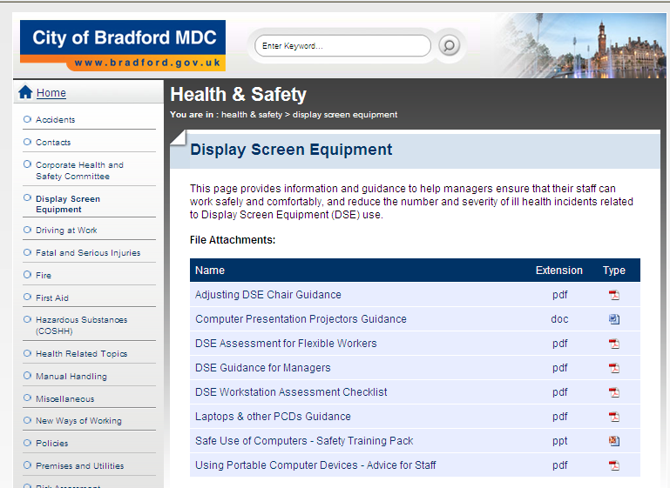

Please email HR Admin on AssistantHROs@bradford.gov.uk with the following information: personnel number, staff name, service and department.
The appropriate health and safety assessments must be completed prior to any member of staff commencing working flexibly, this is to ensure that the Council is compliant with health and safety regulations, non-compliance could result in Occupational Health claims and even complaints to the Health and Safety Executive (HSE).
This includes the Council’s Reporting of Sickness Policy.
IA-003 Information Security Position Statement 1.0
By ‘normal commuting journey’ we mean the average time and mileage that you take to get from home to the designated work base, excluding any deviations from the route, e.g. school run etc.
This is noted in the IT Acceptable Use Policy.
The types of breaks to consider are as follows: - Opportune breaks, Micro breaks, Eye breaks – a short pause in working activities, making/receiving telephone calls, moving about e.g. going to the printer or making a drink. Looking away from the screen (fixed focal length) at different areas of a room or out of a window, to relax the eye muscles and increase the blink rate. Users should adopt the 20 20 20 rule - look at objects 20 metres away for 20 seconds every 20 minutes. - Rest breaks – get up, have a stretch, move about. This should improve blood circulation and get the muscles of the body working again and is very useful when using keyboards for prolonged or sustained keyboard work. These breaks should occur every 30 to 60 minutes and last a few minutes. - Change of activity, Exercise breaks – a different activity e.g. reading document, meetings etc. If task variation is not possible, then the rest breaks must be taken. Workers should be encouraged to stretch and move about to relieve muscle fatigue. This could be a lunch break, getting up and getting away from the computer and not surfing the internet. You should never forgo the lunch break to shorten a working day or indeed stack up breaks to a point later in the day.
Please refer to the Broadband Access requirements for Council Personnel guide
The flexible working arrangement will be discontinued if the productivity levels specified in the Quality and Performance paragraph of this Agreement are not met.
See the equipment checklist on the front page of this Agreement.
Please note that this Agreement and the relevant DSE forms can be signed electronically.

